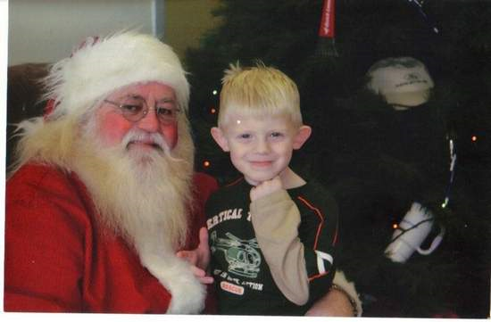

Santa Drives toy drive at Albion Motors Ford-Mercury
Melissa Bunker • Reader Submitted • December 1, 2008
This year we may need the cheer of Santa more than ever. And soon! Thankfully Santa is arriving early this season at Albion Motors Ford-Mercury and we need to show our thanks. The jolly guy will be at Albion Motors Ford-Mercury on Saturday December 6 from 10AM-2PM to collect donations for the Marine Corp's Toys For Tots Campaign.
Every child who visits Albion Motors Ford-Mercury on December 6 with an unopened toy for the Marine Corp campaign gets a free gift from Santa. The event is free of charge. Refreshments are served and no purchase is necessary.
Albion Motors Ford- Mercury with the Quick Lane Tire and Auto Center is located at 1411 N. Eaton Street, in Albion, Michigan. More information is available by phoning (517) 629-9111.
As a thank you Albion Motors Ford Mercury is giving patrons who come on Saturday December 6 a $14.95 oil change coupon for service at Albion's Quick Lane Center. With the service, drivers can start the winter season confident that they will make it over the river and through the woods in safety after a change of oil, a check of tire pressure and a courtesy inspection. Service at Quick Lane is available for any make of car. The service coupon is good for service through December 14.
This is the fourth annual Toys for Tots Campaign at Albion Motors Ford Mercury. Owner Bill Vann says, “There is nothing better than the feeling we get by helping others who are not as fortunate. The Toys for Tots program puts toys right in children's hands- and undoubtedly smiles on their face. What could be better?”
The Marines will pick up toys from Albion Motors Ford Mercury on Monday December 8. Toys can be dropped off anytime before then. “Our goal is to have the barrels overflowing with new toys. After years in this community, I am confident they will be”, adds Vann.
In addition to making sure kids have toys for the holidays, Vann's service manager, Dave Butters, has expanded the program this year to include additional safety tips for parents. He states, “As parents we want childhood to be magical. But if they are not safe, there is no magic- and no childhood.” Mr. Vann has teamed up with the Calhoun County Sherriff's department to offer several safety programs for parents.
Sheriff Al Byam of the Calhoun County Office of the Sheriff is offering a free children fingerprint program for parents. In addition to getting an invaluable set of fingerprints, parents will learn how to collect and keep additional information for their children. Parents will also get more safety tips just in time for seasonal sports. Deputy Todd Turner of Calhoun County Office of the Sheriff will detail safety tips for snowmobiling, ATV use and hunting.
Albion Motors Ford-Mercury is distinguished by its impeccable personal service, competitive prices and Free Service Loaner program. Located 20 seconds off I-94 at exit 121, they will deliver a car anywhere at anytime. More information is available at fordsdirtcheap.com .

